**Appendix A:**

**System Sequence Diagram**

**Appendix A: System Sequence Diagram**

**System Sequence Diagram:**

1. 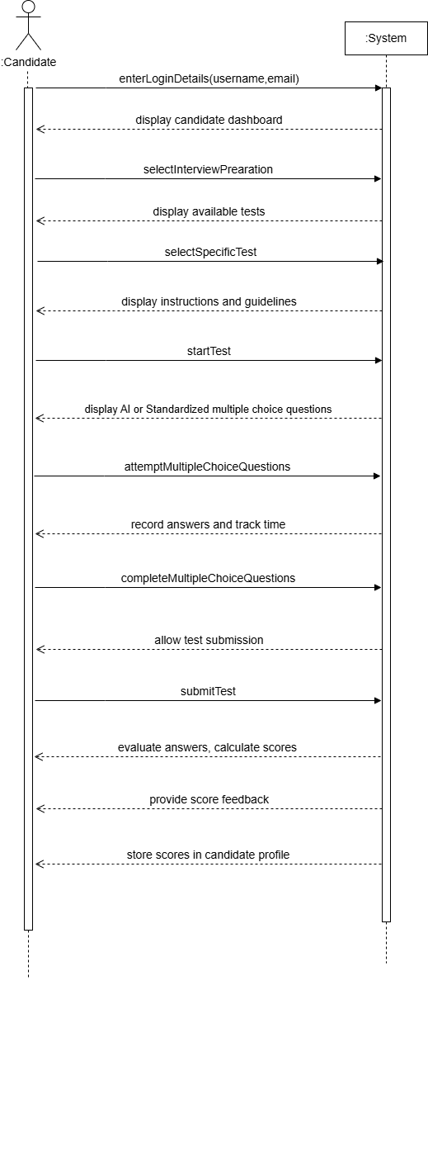**Attempt Test**

Figure 4.8 Attempt Test

1. **Attempt Technical test**

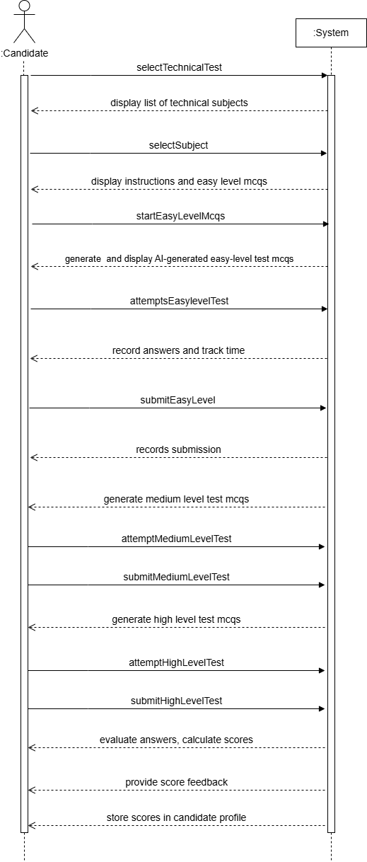

**Figure 4.9 Attempt Technical Test**

1. **Attempt IQ test**

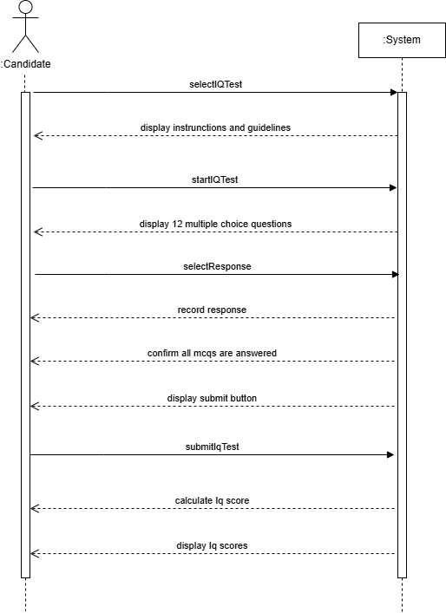

**Figure 4.10 Attempt IQ Test**

1. **Attempt EQ test**

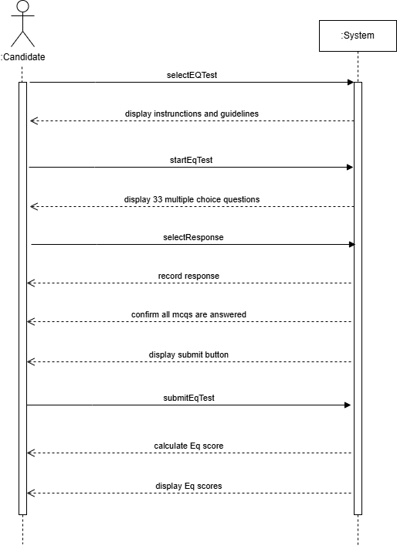

**Figure 4.11 Attempt EQ Test**

1. 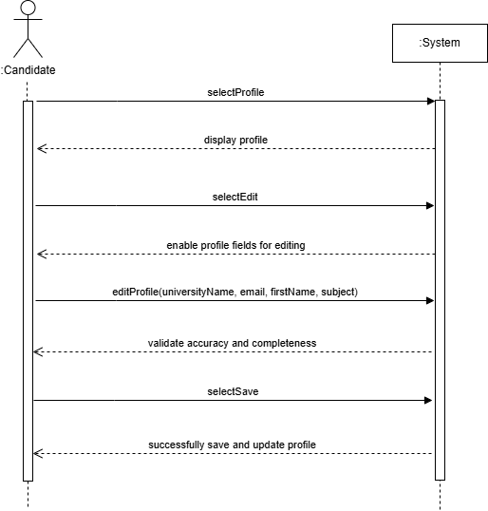**Manage Profile**

**Figure 4.12 Manage Profile**

1. **Manage Resume**

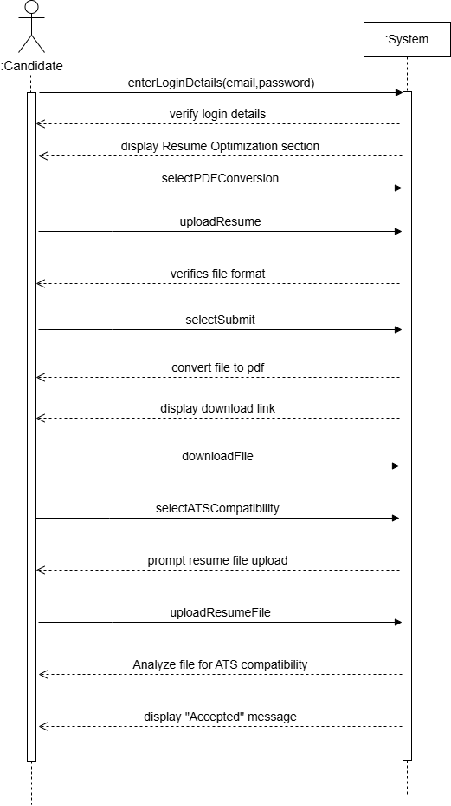

**Figure 4.13 Manage Resume**

1. **Login**

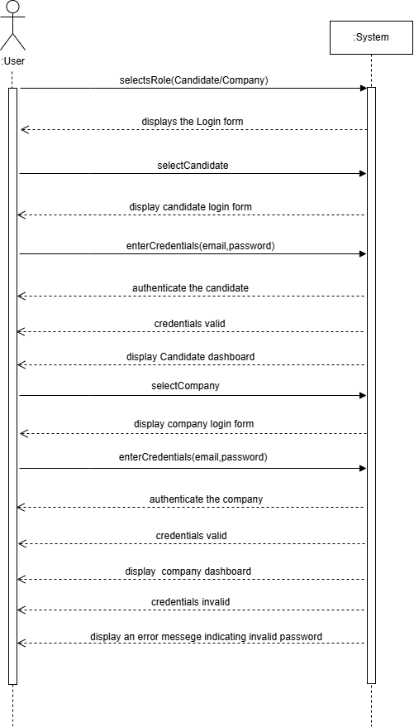

**Figure 4.14 Login**

1. **Signup**

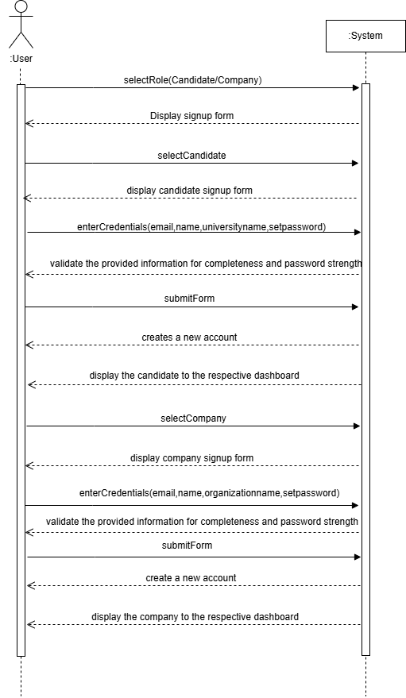

**Figure 4.15 Signup**

1. 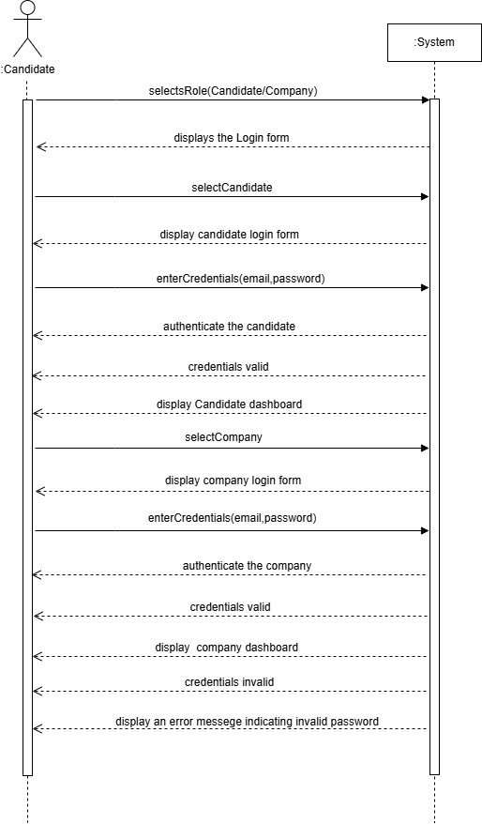**Browse Candidate Profile**

**Figure 4.16 Browse Candidate Profile**

1. **Browse University Analytics**

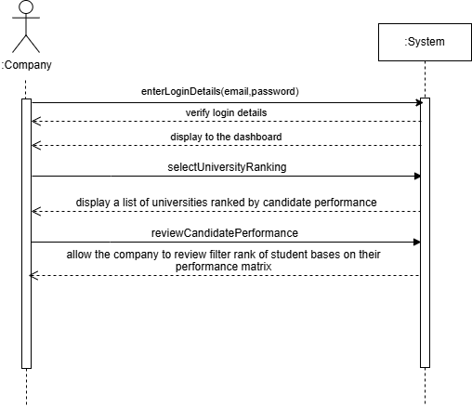

**Figure 4.17 Browse University Analytics**

1. **Question Vault**

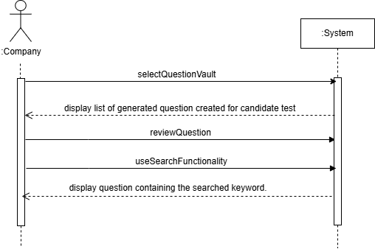

**Figure 4.17 Question Vault**

**Figure 4.8 Signup**

